



DODGERS – SELF MEASURMENT FORM

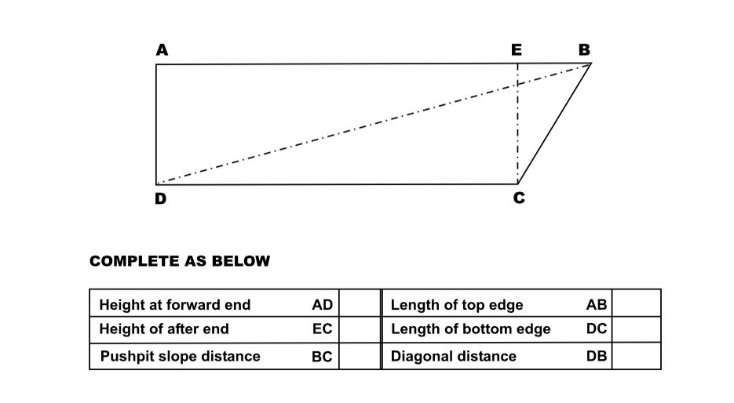

NOTES

* If any cut-outs, pockets or flaps are required please indicate using nearest two sides of datum, for each side as necessary
* Indicate choice of available material and colour
* Indicate any lettering require and colour , also whether separate or hyphenated words are required- Letters are additional to the basic price of the dodgers and are quoted per letter.
* Ascertain whether port and starboard dodgers are identical in shape

**Kemp Sails Limited**, Unit 16 Sandford Lane Industrial Estate, Wareham, Dorset, BH20 4DY

Telephone **01929 554308** Fax **01929 554350**

E-mail: **INFO @KEMPSAILS.COM** Website: [**WWW.KEMPSAILS.COM**](http://WWW.KEMPSAILS.COM)

